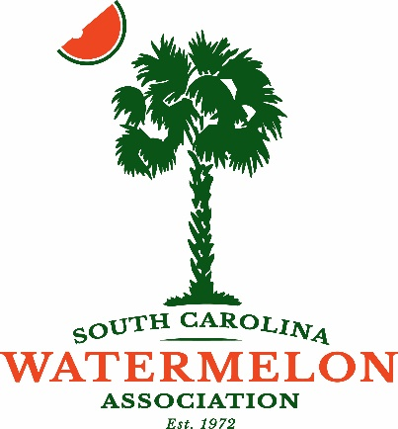
South Carolina Watermelon Association
2023 Annual Convention

January 13-15, 2023
Hilton Head Island, South Carolina

For more information, contact Ginny Gohagan, Executive Director
Mobile: (803) 942-1194 Office: (803) 734-0648 Email: ggohagan@scda.sc.gov

Jubilee Level Sponsors Donation of $2,000 or Higher
- Your logo/Name on signs throughout the Hotel and ability to place your promotional items in registration welcome bags
- Your graphics on the slideshow at the Saturday Lunch Buffet and ability to place your marketing information on the tables during lunch on Saturday
- Your name/logo on the official SCWA Convention Koozie
- Full page ad in the convention program at the Jubilee level (7.5”W x 9.5”H)
- Complimentary Exhibit Space and two Attendee Badges

Allsweet Level Sponsors Donation of $1,500
- Your logo/Name on signs throughout the Hotel
- Ability to place your promotional items in registration welcome bags
- Full page ad in the Program at the Allsweet Level (7.5”W x 9.5”H)
- Complimentary Exhibit Space and two Attendee Badges

Sangria Level Sponsors Donation of $1,000
- Ability to place your promotional items in registration welcome bags
- Half page ad in the convention program at the Sangria Level (7.5”W x 4.5”H)
- One complimentary Attendee Badge
NEW President’s Reception Sponsors Donation of $1,000
- Your logo/name on display during the President’s Reception Friday night
- Ability to place promotional items on tables at the reception
- Half page ad in the Program at the Sangria/Reception Level (7.5”W x 4.5”H)
- One complimentary attendee Badge
Crimson Level Sponsors Donation of $500
- Half page ad in the Program at the Crimson Sweet Level (7.5”W x 4.5”H)

Auction Item Donations
- We greatly appreciate any items you may wish to donate for the live auction. Donors of these items will be recognized during the event.

PLEASE EMAIL ALL SPONSOR ARTWORK TO GGOHAGAN@SCDA.SC.GOV NO LATER THAN DECEMBER 1, 2022 TO ENSURE IT MAKES IT IN THE PROGRAM.
PDF FILE PREFERRED BUT WILL ACCEPT HIGH-REZ 300 PPI JPEG

